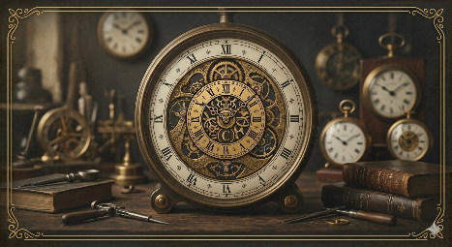

Project Improvement and Implementation Report
Company Name: Chronos Heritage Restorations
Workshop Locations: 12 Heritage Lane, Old Town District | 45 Clockwork Square, New Quarter
Contact Email: craft@chronosheritage.com
Contact Phone: +27 11 555 0123

1. Executive Summary of Improvements
This document outlines the specific technical and structural changes made to the Chronos Heritage Restorations website between Part 1 and Part 2 of the Portfolio of Evidence. Following the feedback received, I have focused on moving away from basic HTML styling toward a more professional, scalable, and responsive architecture.

2. Transition to External CSS Architecture
In the previous submission, I used several inline styles to manage the visual theme. I have now completely removed those and moved all design rules into a dedicated external file named style.css. This change aligns with the module requirements for cleaner code and ensures that the "vintage and precise" aesthetic is consistently applied across all five pages. By using an external stylesheet, the website now loads more efficiently and follows industry best practices for separation of concerns.

3. Structural Refinement and Semantic Coding
Based on the rubric criteria for standards-compliant code, I have overhauled the HTML structure. I moved away from using generic div tags for everything and instead implemented semantic HTML5 elements like <header>, <nav>, <main>, and <footer>. This was a major point in the Part 1 feedback regarding the success indicators for organizational structure. This change makes the site much more accessible and easier for search engines to crawl.

4. Responsive Design and Breakpoint Implementation
A core focus for Part 2 was ensuring the site works on more than just a desktop. I have implemented a responsive grid system using media queries. I set specific breakpoints at 768px and 480px to handle tablets and mobile phones. The navigation menu now shifts from a horizontal bar to a stacked list on smaller screens, which solves the previous issue where links would overlap on mobile views. I also replaced fixed pixel measurements with relative units like percentages and rems to ensure the layout is fluid.

5. Legal Asset Management and Preparation
I took the feedback about legal sourcing seriously for this phase. All images of clock movements and tools have been vetted to ensure they are either public domain or licensed via Creative Commons. Furthermore, I used online optimization tools to resize and compress these images before placing them in my project folder. This ensures the site meets the technical requirement for fast loading times while maintaining the high quality expected for a luxury restoration service.

6. Enhanced Navigation and User Experience
The navigation system is now more functional and interactive. I added CSS pseudo-classes to provide visual feedback, such as color transitions and underlines when a user hovers over a link. I also organized the project files into a clear folder structure with separate directories for images and styles, which makes the entire project more manageable as I move toward the final Part 3 submission.

References
Coyier, C. (2021). A Complete Guide to Flexbox. Available at: https://css-tricks.com/snippets/css/a-guide-to-flexbox/ (Accessed: 29 May 2026).
Duckett, J. (2014). HTML and CSS: Design and Build Websites. Indianapolis: John Wiley & Sons.
Luz, A. (2025). The Role of Digital Platforms in Enhancing the Market Reach of Small Businesses. Preprints.org. Available at: https://www.preprints.org/manuscript/202502.1162 (Accessed: 29 May 2026).
MDN Web Docs (2026). Semantic HTML. Available at: https://developer.mozilla.org/en-US/docs/Glossary/Semantics#semantics_in_html (Accessed: 29 May 2026).
W3Schools (2026). CSS Media Queries - Examples. Available at: https://www.w3schools.com/css/css_rwd_mediaqueries.asp (Accessed: 29 May 2026).

